Internationalization in touch dialog box

Internationalize the filelabels in touch ui dialog box of AEM is achieved using internalizaiton.

* We have dialog box in hero component, where we have 2 fieldlabels
* To translate these field labels, we need to use internatinalization.
* To achieve this we can use a concept of internationalization i18n.

Steps to achieve this:

1. Create i18n node of type sling:folder.
2. Create node with name as language code(ISO code) of the language of type sling:folder.Ex: fr for french and de for germany. Add 2 properties in this node. jcr: language and it's value of language code and add mixin type as mix:language.

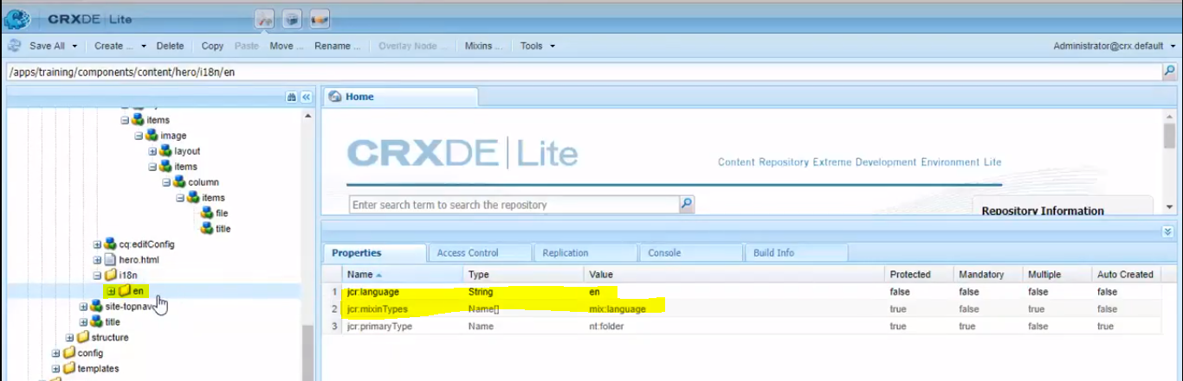

3) Create child node of type sling:messageEntry with property sling:message which should have fieldlabel in the different languages (sling key doesn’t require here).

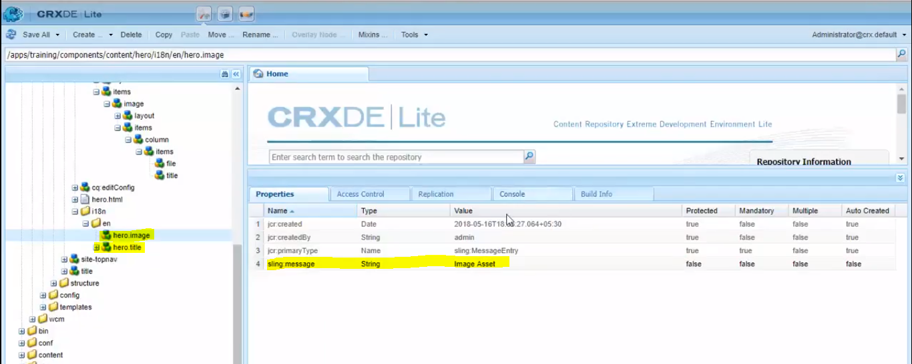

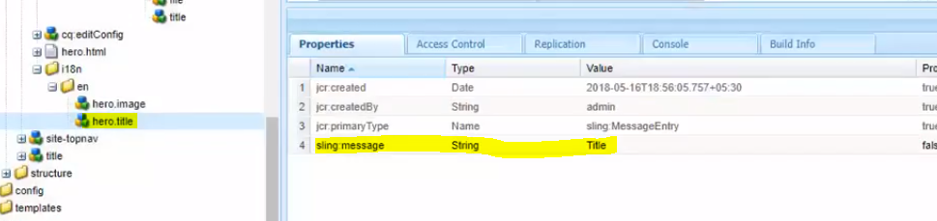

4 ) As a next step, go to the dialog fields, and change the fieldLabel values to the node names we have created in the internalization nodes.

In this case, for “Image Asset” fieldLabel value, we should map “hero.image” and similarly for “Title” we should map “hero.title”.

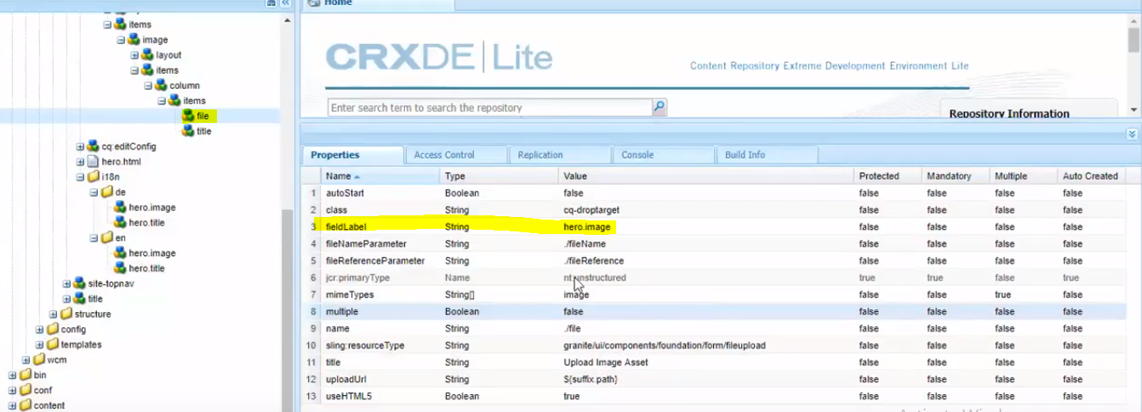

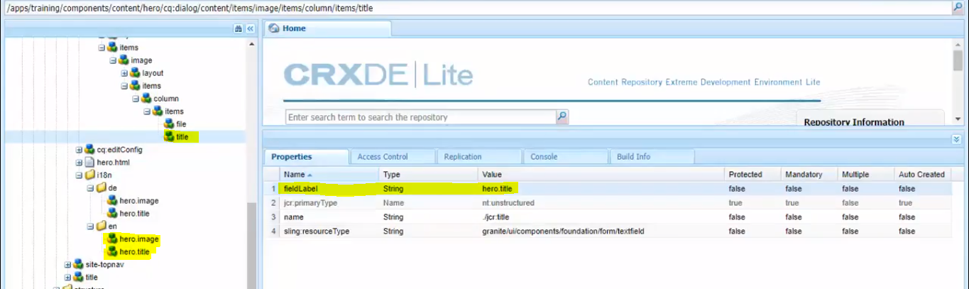

5 ) To see the changes in the dialog, go to User Admin console(<http://localhost:4502/useradmin> ), and search for the user (this case, it is **admin**) and change the language preference to the once you want to provide.

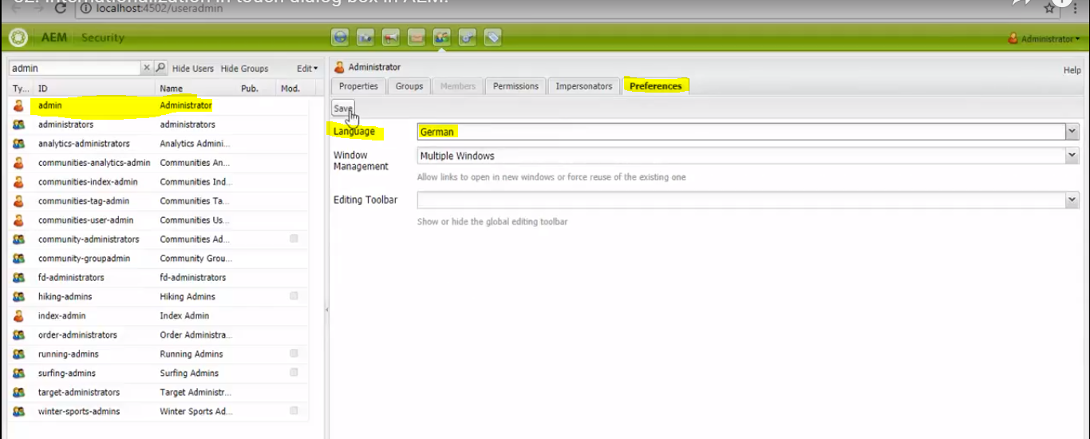

6 ) The final output looks like the below screenshot. As we have opened German page, labels that we have specified under German language folder will be applied for the dialog fieldLabels.

